

**Continuing Education**

**Fall Sesion is Oct. 7 through Dec. 20, 2024**

1103

ext.

518-765-3313

VCSD 432 New Salem Rd, Voorheesville, NY 12186

jaugar@voorheesville.org

**www.voorheesville.org**

**w**

**w**

**w**

**.**

**v**

**o**

**o**

**r**

**h**

**e**

**e**

**s**

**v**

**i**

**l**

**l**

**e**

**.**

**o**

**r**

**g**

**\***

**\***

**\***

**\***

**\***

**\***

**E**

**C**

**R**

**W**

**S**

**S**

**\***

**\***

**\***

**\***

**\***

**\***

**P**

**O**

**S**

**T**

**A**

**L**

**C**

**U**

**S**

**T**

**O**

**M**

**E**

**R**

**N**

**o**

**n**

**-**

**P**

**r**

**o**

**f**

**i**

**t**

**O**

**r**

**g**

**.**

**U**

**.**

**S**

**.**

**P**

**o**

**s**

**t**

**a**

**g**

**e**

**P**

**A**

**I**

**D**

**P**

**e**

**r**

**m**

**i**

**t**

**N**

**o**

**.**

**A**

**l**

**b**

**a**

**n**

**y**

**,**

**N**

**Y**

# Eligibility for Classes

Courses are open to all persons in the Capital District region with priority given to VCSD residents when necessary. Middle and High

School students are welcome to register as well. Registration must be made in advance of the classes to be eligible to participate.

# Cancellations, Inclement Weather & Contingency Days

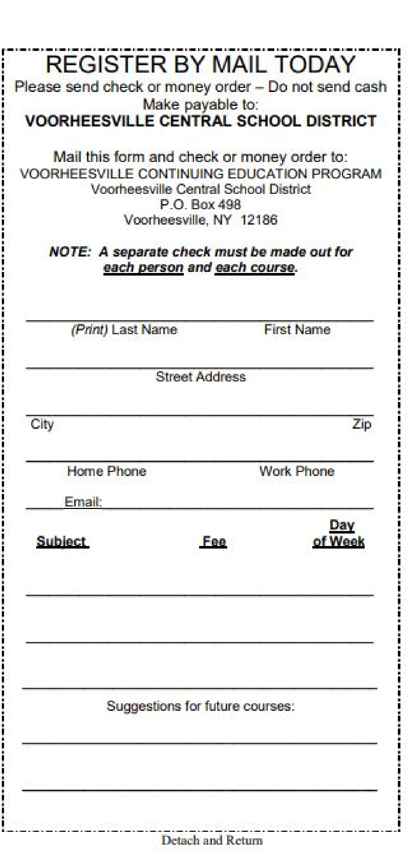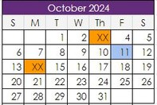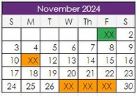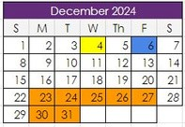

**www.voorheesville.org**

**Fees and Refunds**

Registrations fees are payable when you register. Fees are

listed in the brochure.

A separate check/money order must

be made out for each course you sign up for. DO NOT SEND

CASH. Refunds will not be given after the first class has been

held. There are no refunds for missed sessions. Checks will

not be cashed until the class begins.

Classes will be canceled when school is canceled or closed early due to inclement weather, unsafe conditions, or an

emergency. Please check the district website or your local television station to get the latest information on school closings. **No school means no class.** There will not be any classes on dates noted in with an XX on the date. Individual teachers will review their schedules with each class and .

**Fall Session Oct. 7 - Dec. 20, 2024**

# Online Registrations

You can pay for classes online at: [https://www.myschoolbucks.com](https://www.myschoolbucks.com/)

Once on the homepage follow these steps to register

Click browse all items

View details on Continuing Education

Select a course from the options menu; click the down arrow Fill out online registration and “Add to Basket”

If you register for more than one course, after adding a class to the basket you will automatically return to view details to select another course.

Please note that “Heartland” will add a convenience fee to the total payment amount to your purchase

# Mail-in Registrations

If you choose to submit your registration by mail, fill out the attached registration form, enclose the correct fee (checks made payable to Voorheesville Central School District) and send to:

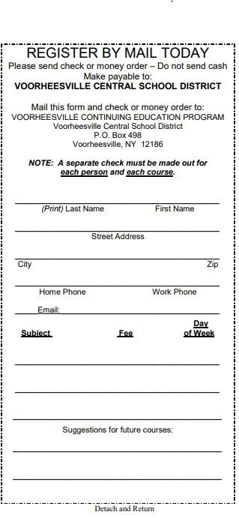

**www.voorheesville.org**

**VCSD Continuing Education Classes**

Jennie Augar,

Director of Continuing Education

Voorheesville CSD

P.O. Box 498

Voorheesville, NY 12186

Registrations close on September 30, 2024.

LATE registrations will be accepted IF there is room in the class. You will not receive confirmation of registration. You will be notified only if a class is full or canceled.

**Any questions? Contact us!**

Jennie Augar - Director

518-765-3313 ext. 1103 jaugar@voorheesville.org

Joseph Sapienza - Director jsapienza@voorheesville.org

**VCSD Continuing Education Classes**

## Shallow Water Aerobics

**Location: High School Pool Instructor: Decker**

**Day/Time: Mon 6 pm-7 pm**

**Fee: $70.00 Senior Discount: $40.00 Sessions: 11**

Course Description: Join us for a fun shallow water workout choreographed to popular music that targets cardiovascular fitness,

muscle tone, core strength, flexibility, and balance. Using the properties of the water we will maximize your training while putting less impact

on your joints. Exercises can be adapted to all levels and will focus on upper and lower body moves incorporating intervals of plyometric

jumps, dance, squats, and speed drills. Bring your water bottle and a

smile on your face. The class will run for one hour with a warm-up and cool-down

## Deep Water Aerobics

**Location: High School Pool Instructor: Decker**

**Day/Time: Mon 7:15 pm -8:15 pm**

**Fee: $70.00 Senior Discount: $40.00 Sessions: 11**

Course Description: If you love a good workout and would benefit from no stress on your joints then Deep Water Aerobics is the class for you . The

increased resistance allows for a good cardio work out while using a deep

water floatation belt to stay afloat and maintain good posture. Guaranteed to burn calories and increase muscle mass we will complete a

choreographed cardio workout to a variety of popular music and end with

toning and stretching exercises. The class will run for one hour with warm up and cool down. A swim/float jogging belt can be purchased ahead at

https://www.swimoutlet.com/search?q=jog+belt Sporti and Speedo offer less expensive options than hydro-fit, which is top of the line.

### Fall Session Oct. 7 - Dec. 20, 2024 Men’s Recreational Basketball

**Location: HS Gym - Instructor: Bollentin**

**Day/Time: Mon & Wed-8 pm - 10 pm**

**Fee: $125.00 Sessions: 22**

Course Description: This *is course is intended for adults who want to work off some of the week’s tension in a routine,*

*informal game of basketball.* ***CASH IS NOT ACCEPTED*** *FOR CLASS PAYMENT No Senior discount for this class.*

## Lap Swim

**Location: HS Pool**

**Day/Time: Tue 8-9 pm & Wed 7-9 pm**

**Fee: $40.00 Sessions: 11**

Course Description: Swimming laps is a good way to get in shape and/or maintain physical fitness. Three

lap swim lanes will be available for fast, medium, and slow swimmers at their own pace. No senior discount for this class.

## Open Swim

**Location: HS Pool**

**Day/Time: Saturdays 1-3 pm**

**Fee: Adults $2/Children $1. Sessions: 11**

Course Description: Back by popular demand.

Swimming is a good way to get in shape and/or maintain physical fitness. Come use the pool and have some fun. All Children under 12 must be accompanied by an adult while on school premises. No senior discount for this

class. Registration not required, just pay the lifeguard on arrival. 

**www.voorheesville.org**

|  |
| --- |
| **VCSD Continuing Education Classes Fall Session Oct. 7 - Dec. 20, 2024** |

### Women’s Recreational Basketball

**Location: M.S. Gym Instructor: C. Kelley**

**Day/Time: Weds 8 pm -10 pm**

**Fee: $60.00 Sessions: 11**

Course Description: This course is designed for women looking to get in shape through a weekly game of fun, non-competitive

basketball. Beginners and veterans alike are invited to play.

## Yoga

**Location: HS Commons Instructor: Goodbee**

**Day/Time: Mon & Wed 6-7 pm**

**Fee: $70.00 Senior Discount: $35.00 Sessions: 22**

Course Description: From Yogi Goodbee: “It will be an honor & a privilege to share the many gifts of yoga, mindfulness, and meditation in this

community class, as we build bridges of connections. Come one, come all, short or tall, big or small. This is an invitation for you all. To help you stand nice and tall, we probably find ourselves on all fours, maybe our

legs up on a wall, we may even begin to crawl, pulse, arc, wave, and roll!

It'll be a lighthearted way to de-stress, focus, and to energize our body and soul. All abilities are welcome from newbies to advanced yogis. I

suggest that you wear comfortable clothing, bring whatever props you like, your own mat and perhaps a blanket to cover up during our

relaxation time, and water so that you stay hydrated. Lastly bring an open heart, and an attitude of "I can!”. There will not be class on 10/7/24

### Co-ed Volleyball

**Location: MS Gym Instructor: Liddle**

**Day/Time: Tues 8 pm 10 pm**

**Fee: $60.00 - Sessions: 11**

Course Description: This course is designed for the novice player to review the basic aspects of Volleyball. This is meant to be a recreational class, with an emphasis on playing the game and having fun. The Class limit is 30 participants. No Senior discount for this class.

#### Exercise & Fitness for Everyone

**Location: VES Big Gym - Instructor: Massaroni Day/Time: Mon & Thurs 7:30 pm - 9 pm**

**Fee: $60.00 *Senior Discount: $30.00 Sessions: 22*** Course Description: *This class incorporates all genres of fun music to work out for all ages. Class starts with a warm-up/walk, then flows to simple, easy-to-follow dance/Zumba-type moves. We work with stretch bands, light free weights; do some balance work, muscle*

*building, and even do a fun core workout in a chair. We will have cool down, relaxation, stretching, and massage during the last 30 minutes of class. We turn the lights down low and enjoy simple yoga poses to increase flexibility and then relax through breathing techniques and self-massage of the face, head, and neck. Hydrate before class and*

*bring an exercise mat or thick towel, a water bottle, a stretch band (if you have one), and light free weights.*



|  |
| --- |
| **VCSD Continuing Education Classes Fall Session Oct. 7 - Dec. 20, 2024** |

## Fall Greeting Card Making

**Location: HS Art Room**

**Instructor: J. Mulligan of Jo’s Craft Corner, LLC**

**Day/Time: Monday, Oct 7, 2024 6-8 pm**

**Fee: $30.00**

Course Description: In this class you will create four fall holiday cards; two Halloween and two Thanksgiving. Please bring a pair of sharp scissors and adhesive such as

double-sided tape to class, all other supplies will be provided by the instructor.

## Fall Scrapbooking

**Location: HS Art Room**

**Instructor: J. Mulligan of Jo’s Craft Corner, LLC**

**Day/Time: Monday, Oct 21, 2024 6-8 pm**

**Fee: $30.00**

Course Description: In this class you will be making a double page 12” x 12” Fall or Halloween scrapbook layout, your

choice. You will pick which layout you prefer the day of class.

Although photos are not necessary, feel free to bring a selection of photos that you would like to use. We will be

using stamps, ink and specialty paper for this project. Please bring a pair of sharp scissors and adhesive to class, all other supplies will be provided by the instructor.

## Christmas Scrapbooking

**Location: HS Art Room**

**Instructor: J. Mulligan of Jo’s Craft Corner, LLC**

**Day/Time: Monday, Oct 28 , 2024 6-8 pm**

**Fee: $30.00**

Course Description: In this class you will be making a double page 12” x 12” Christmas scrapbook layout.

Although photos are not necessary, feel free to bring a selection of photos that you would like to use. We will

be using stamps, ink and specialty paper for this project.

Please bring a pair of sharp scissors and adhesive such as double-sided tape to class, all other supplies will be provided by the instructor.

## Christmas Card Making

**Location: HS Art Room**

**Instructor: J. Mulligan of Jo’s Craft Corner, LLC**

**Day/Time: Monday, Nov. 4, 2024 6-8 pm**

**Fee: $30.00**

Course Description: Your friends and family will love receiving beautiful Christmas cards hand made by

you! In this class you will be creating 4 Christmas cards using rubber stamp images, inks, and specialty paper.

Please bring a pair of sharp scissors and adhesive such as double-sided tape to class, all other supplies will be provided by the instructor.

